COMPUTER NETWORK SKILL 1
Aim
To capture network packets and understand how Ethernet, IP and TCP/UDP headers are added during data transmission. The experiment examines packet headers, calculates header overhead and determines how efficiently the network carries application data.
Introduction
Whenever data travels through a computer network, each protocol layer adds its own header to the data. These headers introduce overhead. Using Wireshark, real network packets are captured and their Ethernet, IP and TCP/UDP headers are examined. The total overhead and payload efficiency are then calculated.
Requirements
A computer connected to the internet through Wi-Fi or Ethernet.
Wireshark packet-analyzer software.
A web browser to generate network traffic.
Procedure
Step 1: Install Wireshark
Open a web browser.
Visit the official Wireshark download page and download Wireshark.
Install Wireshark using the default installation settings.
Open Wireshark after installation.
Step 2: Select your network interface
When Wireshark opens, check the available interfaces, such as Wi-Fi, Ethernet and Bluetooth.
If the computer is connected through Wi-Fi, select the Wi-Fi interface. If it is connected through a cable, select Ethernet.
Double-click the selected interface to start packet capture.
Step 3: Generate network traffic
Keep Wireshark capturing packets.
Open a new browser tab.
Visit a website such as https://www.google.com.
Open two or three different websites.
Wait for approximately 30 seconds so that packets are generated.
Return to Wireshark and click the red Stop button.
The captured packets should now be visible in the packet list.
Step 4: Apply display filters
Locate the display-filter bar at the top of the Wireshark window.
Enter each filter separately and press Enter.
Use tcp to display TCP packets.
Use udp to display UDP packets.
Use icmp to display ICMP packets.
Use tcp.len > 0 to display TCP packets carrying data.
First enter tcp and observe the displayed packets. Then enter udp and observe the UDP packet

OUTCOMES FROM THE WIRESHARK
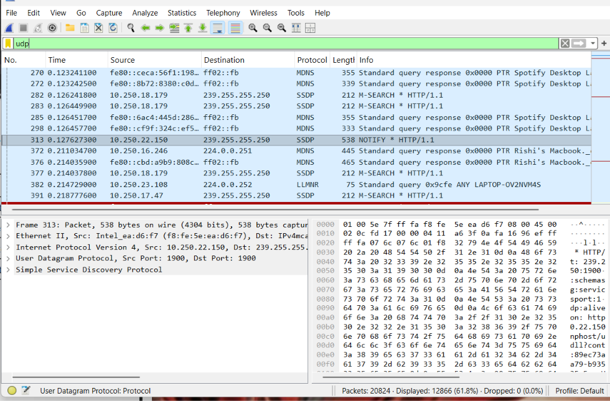

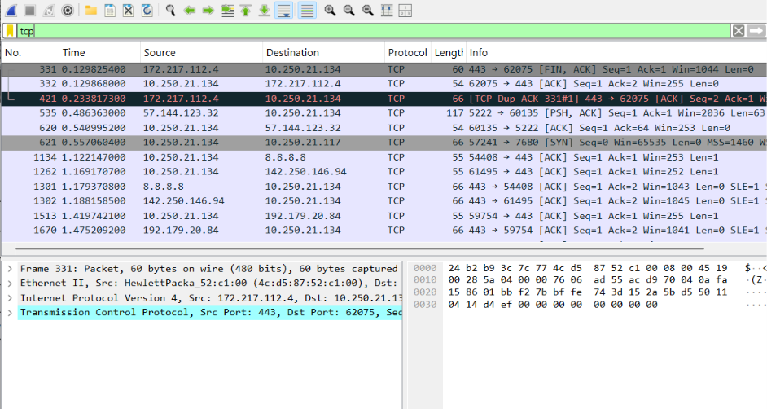

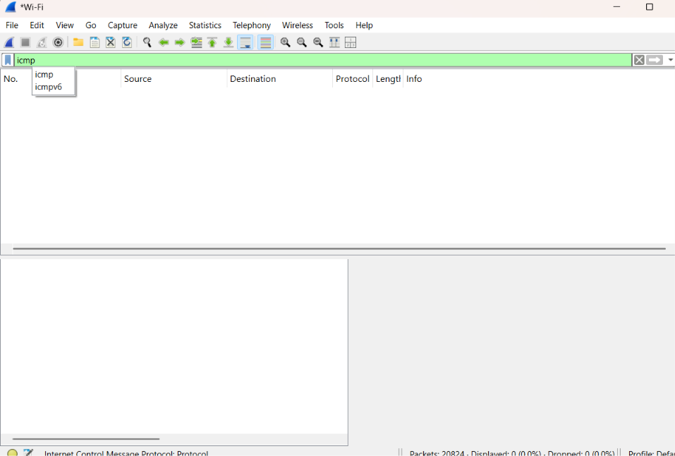
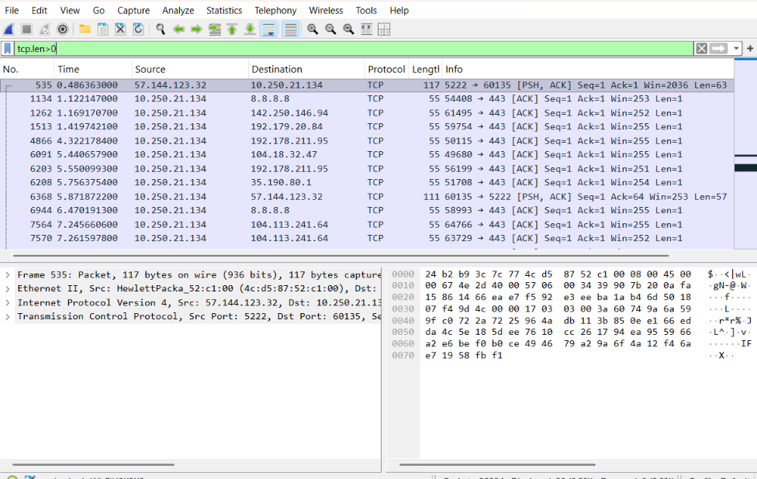

Parameter | TCP Packet | UDP Packet
Frame Length | 66 bytes | 86 bytes
Ethernet Header Length | 20 bytes | 20 bytes
IP Header Length Transport | 20 bytes | 20 bytes
Header Length IP Total | 52 | 72
Length Transport Header | 32 bytes | 52
Length Payload Length | 12 bytes | 44 bytes

